MEETING ROOM SCHEDULER
@CREATIVITY THINK (9483175986/7019689991)

ABSTRACT:
Meeting Room Scheduler is a web-based application designed to manage room bookings efficiently for offices, co-working spaces, and colleges. The system enables users to search available rooms, book single or multiple slots, receive reminders, and track bookings through an interactive dashboard. Administrators can manage room schedules, handle booking requests, resolve conflicts, and generate analytics reports. Developed using Django and Django Rest Framework for the backend, and React with redux and react-calendar for the frontend, the platform provides a secure, streamlined, and scalable solution for room scheduling and resource management..

INTRODUCTION OF THE PROJECT:
Manual scheduling of meeting rooms often leads to conflicts, overlapping bookings, and inefficient usage of resources. Existing systems may lack automated reminders, calendar integration, and administrative control. Meeting Room Scheduler addresses these challenges by providing a centralized, web-based solution that allows users to reserve rooms, receive timely notifications, and monitor booking status. Administrators gain complete oversight of schedules, bookings, and resource allocation through analytical dashboards. This approach ensures better utilization of spaces, reduces conflicts, and enhances organizational efficiency..

PROJECT OBJECTIVES:

• Provide a web platform for booking meeting rooms
• Enable single and multi-slot bookings for flexible scheduling
• Allow users to view availability through an interactive calendar
• Send reminders and notifications for upcoming bookings
• Enable administrators to add and manage rooms and schedules
• Track all bookings and resolve conflicts efficiently
• Generate dashboard analytics for better resource management
• Ensure secure, real-time updates and scalable system performance

PROBLEM OF THE STATEMENT:
Organizations often face challenges in managing meeting room schedules due to overlapping bookings, inefficient manual tracking, and lack of automated notifications. Users struggle to confirm bookings or identify available slots, while administrators lack a comprehensive overview of room usage. Meeting Room Scheduler provides a centralized and automated solution to track, manage, and optimize room bookings, eliminating conflicts and enhancing overall operational efficiency..

MOTIVATION OF THE PROJECT:
• To replace manual booking and scheduling processes
• To improve resource utilization and reduce conflicts
• To provide automated reminders and calendar integration
• To enhance user experience through real-time availability and dashboards
• To allow administrators complete control over room management
• To provide analytical insights for operational improvement
• To offer a scalable and secure web-based scheduling system

BLOCK DAIGRAM OF PROJECT:

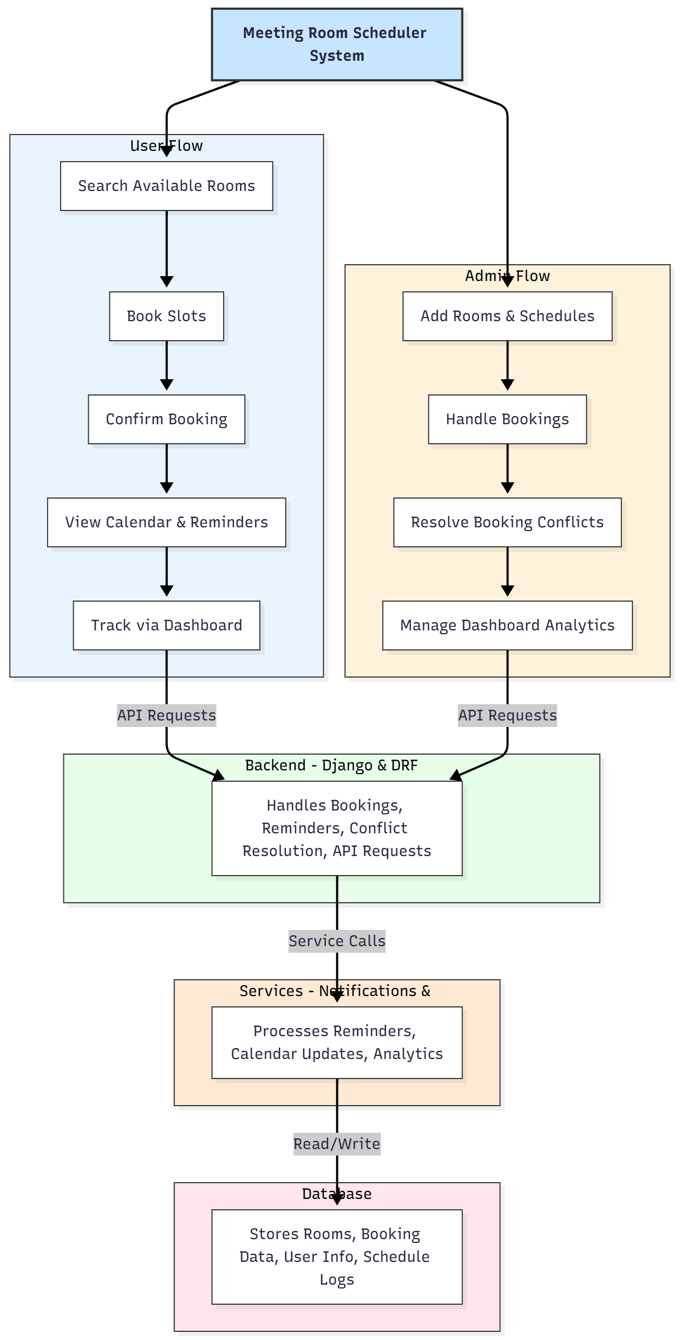

WORKING OF THE PROJECT:
The system begins with administrators adding rooms and their schedules. Users can search for available rooms, select desired time slots, and confirm bookings. The backend validates availability and updates the database accordingly. Automated reminders notify users of upcoming bookings, while the calendar view shows scheduled slots. Administrators monitor all bookings, handle conflicts, and maintain the dashboard for analytics. The services module handles notifications, calendar updates, and generates analytical insights, while the database stores room details, booking history, and user data, ensuring accurate and conflict-free scheduling..

SOFTWARE REQUIREMENT:
- Backend:
  - Python 3.x
  - Django
  - Django REST Framework
  - SQLite/PostgreSQL
- Frontend:
  - Node.js and npm
  - React.js
  - Axios
- Development Tools:
  - Visual Studio Code
  - Postman (for testing APIs)
  - Git/GitHub (for version control)
- Server/Deployment (Optional):
  - Gunicorn, Nginx, or Heroku/AWS for hosting

ADVANTAGES OF THE PROJECT:

• Efficient management of meeting room bookings
• Single and multi-slot booking capability
• Automated reminders and notifications
• Conflict resolution for overlapping bookings
• Dashboard analytics for tracking usage and performance
• Real-time availability and calendar view
• Reduces manual errors and scheduling conflicts
• Enhances organizational productivity and resource utilization

APPLICATIONS OF THE PROJECT:
• Corporate offices
• Co-working spaces
• Colleges and educational institutions
• Conference and seminar scheduling
• Shared resource management in organizations
• Event and meeting management systems

REFERENCES:

- Django REST Framework Documentation — Django Software Foundation. Django Documentation. Available: https://docs.djangoproject.com/
- Django REST Framework. DRF Documentation. Available: https://www.django-rest-framework.org/
- React. React Official Documentation. Available: https://reactjs.org/docs/getting-started.html
- Redux. Redux Documentation. Available: https://redux.js.org/introduction/getting-started
- PostgreSQL Global Development Group. PostgreSQL Documentation. Available: https://www.postgresql.org/docs/
- MySQL. MySQL Reference Manual. Available: https://dev.mysql.com/doc/
- Git. Git Documentation. Available: https://git-scm.com/doc
- Node.js. Node.js Documentation. Available: https://nodejs.org/en/docs/
- Axios. Axios Documentation. Available: https://axios-http.com/docs/intro
- Socket.io Documentation – https://socket.io/docs/

